Promoting Tahlequah High School’s 24/7 Tobacco Free Campus Policy
In November 2005, the Tahlequah School Board was the first in the county to adopt a 24/7 tobacco free school policy, which prohibits tobacco use on school property and at school events for everyone, at all times, even when school is out of session. These policies are the most effective school intervention to reduce student tobacco use and decrease positive attitudes towards smoking.¹

These policies create the safest learning environment for children and they will make a difference in the lives of students. They begin to create a new norm; young people who want and expect to live in communities free of cigarette smoke, and free of tobacco addiction.

Communicating and enforcing a 24/7 policy is critical to its effectiveness.² Some of the best ways to promote these policies include:

- Posting signs around campus
- Announcing the policy at school events
- Including the policy in school materials (handbooks, websites, newsletters, etc.)

Last year SWAT youth surveyed Tahlequah High School to see how they promote their 24/7 tobacco free policy. Students collected information on where signage was posted, how many announcements about the policy were made during athletic events, and whether or not the policy was included in school materials. Here is what they found…


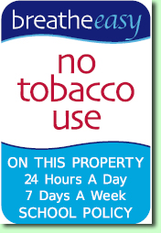
SIGNAGE

- Signs were posted at some main
entrances, around the perimeter of
the property, near the office, and near
spectator areas at the athletic fields.

- Recommendation: Update current
signage and post additional signs
around campus focusing on the following
places: parking lots, auditoriums, gyms,
athletic field bleachers and district vehicles.

ANNOUNCEMENTS

- SWAT youth collected information during a Tahlequah High School home football game.
- 24/7 materials were distributed prior to the game, and announcements about the policy took place in the 2nd and 4th quarters.
- Compliance with the policy was high inside the stadium. No tobacco use was observed before, during or after the game.

- Tobacco use was regularly observed outside of
the stadium throughout the game.

- Recommendation: Remove all ash trays from school property.
- Continue announcements about the policy at athletic events, noting that the policy covers all school property including parking lots.

MATERIALS

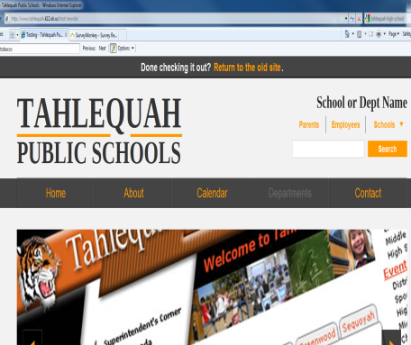
- Policy information is included in school handbooks, fliers and signs.

- Recommendation:
Include the policy in
orientation materials,
school newsletters
and on the school
website.

